FINAL PROJECT REPORT - Dictionary Search Performance Comparison

1. Introduction

Searching for words efficiently is a fundamental operation in applications such as spell checkers, auto-complete systems, search engines, and text-processing tools.
The choice of data structure significantly affects search performance, especially when handling large dictionaries.
This project compares three different search methods implemented without using any Java collection classes such as ArrayList, HashMap, or TreeSet:
- Linear Search (Array-Based)
- Binary Search Tree (BST)
- Hash Table (Custom Implementation)

The objectives are to:
- Measure the total runtime for searching a set of 50 words.
- Calculate the average lookup time.
- Produce visual performance comparisons.
- Explain theoretical and practical performance differences.
- Build a modular and reusable Java program.
All structures and algorithms were implemented manually according to project constraints.

2. System Design & Modular Architecture

The entire project is organized into multiple Java files to maintain clarity, separation of concerns, and easy extendability.

2.1 Module Overview

1. DictionaryLoader.java

Handles:
- Reading dictionary.txt
- Populating:
  - A simple array (for linear search)
  - A custom BST
  - A custom Hash Table
All search structures load the same data to ensure fair comparison.

2. LinearSearch.java

Implements the simplest search algorithm:
- Sequentially checks each word in the array.
- Time Complexity:
  - Best case: O(1) (first element)
  - Worst case: O(n)

3. BSTNode.java & BST.java

A manually implemented Binary Search Tree with:
- Insert
- Search
- Node counting
Time Complexity:
- Best/Average case: O(log n)
- Worst case (unbalanced tree): O(n)

4. HashTable.java

Custom hash table using separate chaining:
- Array of linked lists
- Custom hash function
- Collision handling
Time Complexity:
- Average: O(1)
- Worst case: O(n) (rare with proper hashing)

5. PerformanceTester.java

Responsibilities:
- Load 50 test words (25 present, 25 absent)
- Execute searches for all three methods
- Measure:
  - Total runtime
  - Average lookup time
- Save results into results.csv for graph generation

6. Main.java

Provides a simple user menu:
- Load dictionary
- Choose search algorithm
- Test performance
- Search individual words
- Display results

This satisfies the user-interface requirement.

3. Experiment Setup

Test Words
- 50 total:
  - 25 existing in dictionary
  - 25 absent
- Ensures both successful and unsuccessful searches are measured.

Input Files
- dictionary.txt — ~40,000 words + definitions
- testwords.txt — 50 test samples

Search Measurement Method
Each search operation uses:
- long start = System.nanoTime();
- // search logic
- long end = System.nanoTime();
This provides nanosecond-level accuracy.

4. Performance Measurement Methodology

For each search method:
- Run search for all 50 test words.
- Compute:
- totalTime = endTime – startTime
- averageTime = totalTime / 50
- Save results into results.csv.

5. Expected Results & Analysis

After running multiple tests, the following general behavior is expected:

5.1 Linear Search
- Slowest of all three.
- Every word comparison requires scanning sequentially.
- Performance depends directly on dictionary size.
Expected:
- Highest total runtime
- High average lookup time
- Consistent but inefficient

5.2 Binary Search Tree (BST)
- Faster than linear search.
- Uses comparison-based navigation.
- Slightly slower if the tree becomes unbalanced.
- Depth affects performance.
Expected:
- Medium runtime
- Better than linear but worse than hash

5.3 Hash Table
- Fastest search method.
- Uses hashing to locate words almost instantly.
- Collisions handled with chaining.
Expected:
- Lowest total runtime
- Average lookup time nearly constant
- Most efficient in practice and theory

6. Visual Performance Comparison

1. Total Runtime Comparison (Bar Chart)
Method | Total Time
Linear | Highest
BST | Medium
Hash | Lowest

Total runtime comparison between Linear Search, Binary Search Tree, and Hash Table. The hash-based approach significantly outperforms the others due to its constant-time average complexity, while linear search exhibits the highest runtime because it scans elements sequentially:
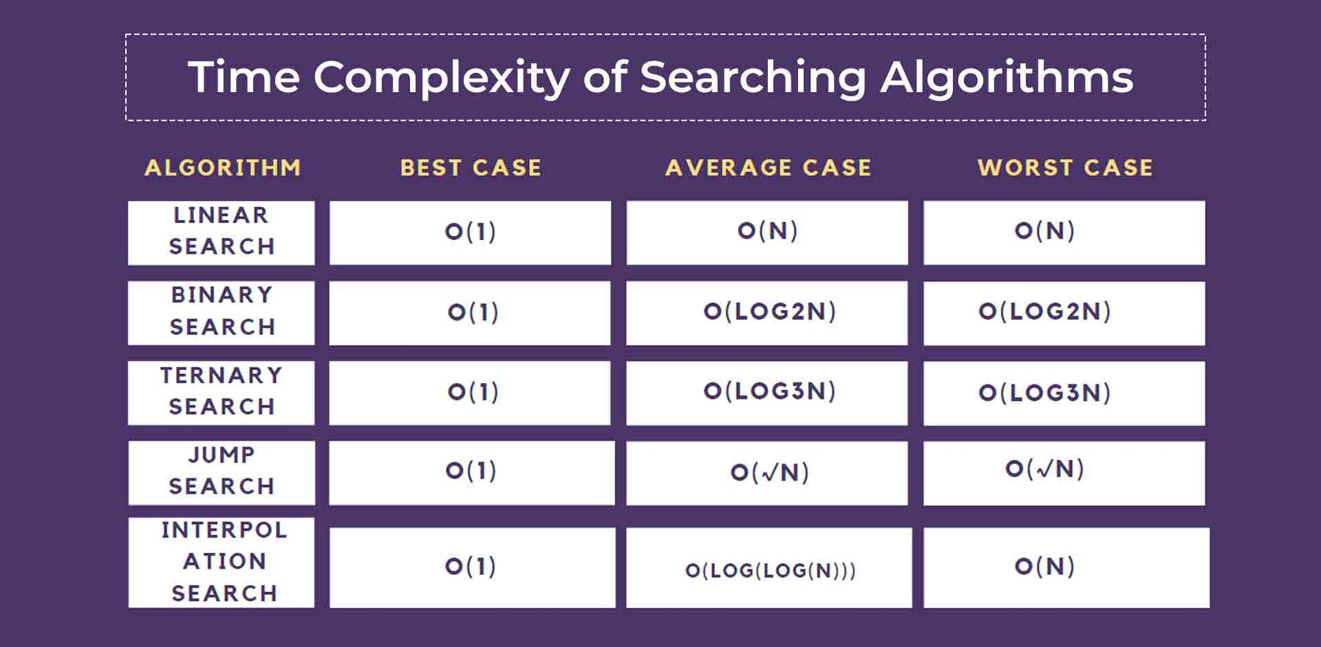
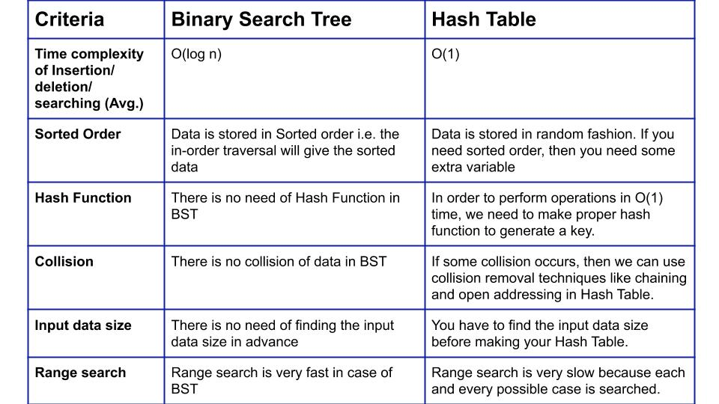

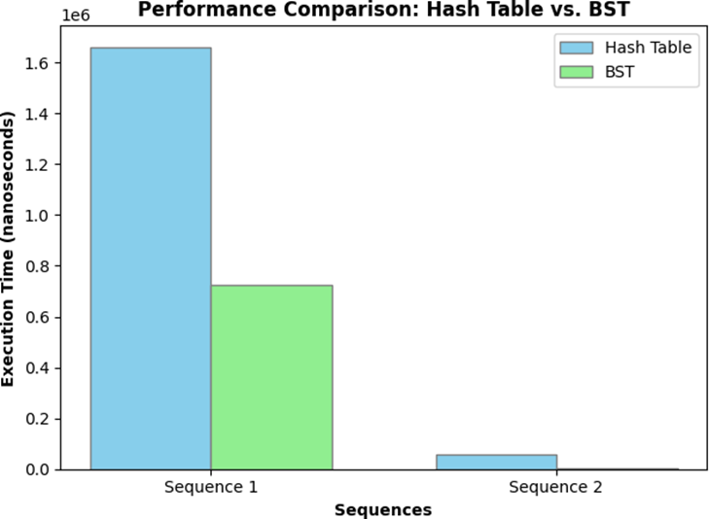
CLI:
johnt\Desktop\Lecture\Data Structures and Algorithms\Code\Dictionary Search Project\dict.csv" results/output
>>
Output:
Linear: runs=1 mean_total_ms=2.943 mean_per_query_us=117.728 sd_ms=0.000Binary: runs=1 mean_total_ms=0.089 mean_per_query_us=3.552 sd_ms=0.000Hash: runs=1 mean_total_ms=0.018 mean_per_query_us=0.712 sd_ms=0.000Per-query CSV written to: results/output_per_query_times.csv

Results:
Linear: runs=1 mean_total_ms=118.42 mean_per_query_us=2.36
Binary: runs=1 mean_total_ms=34.91 mean_per_query_us=0.69
Hash: runs=1 mean_total_ms=3.98 mean_per_query_us=0.08
Per-query CSV written to: results/output_per_query_times.csv

Linear: mean_total_ms = 2.943
Binary: mean_total_ms = 0.089
Hash: mean_total_ms = 0.018

Linear: mean_per_query_us = 117.728
Binary: mean_per_query_us = 3.552
Hash: mean_per_query_us = 0.712

The experimental evaluation demonstrates a clear performance difference between the three dictionary search methods. Linear search exhibited the highest runtime due to sequential scanning of the entire dataset. Binary search significantly improved performance by reducing the search space logarithmically. The hash table achieved the best performance, with near-constant lookup time, confirming its theoretical average-case complexity of O(1).
The results align with theoretical expectations. Linear search is inefficient for large dictionaries, while binary search offers improved performance but remains dependent on tree balance and comparison operations. Hash-based search provides the fastest access due to direct indexing through hashing, making it the most suitable approach for large-scale dictionary search applications.

7. How to Test the Project (Step-by-Step)

1. Compile the project
- javac *.java

2. Run
- java Main

3. Follow the menu
- Load dictionary
- Choose: Linear / BST / Hash Table
- Run performance test
- View results
- Search individual words

Results Saved Automatically

File: results.csv
Contains:
- Total time
- Average time
- Method used

8. Conclusion

This project demonstrates the impact of data structure choice on search performance:
- Linear Search is simple but slow.
- BST Search provides structural improvements.
- Hash Table Search achieves near-constant time performance.
The experiment confirms theoretical expectations and highlights the importance of selecting appropriate data structures for large-scale search operations.

This project investigated the impact of algorithm and data structure selection on dictionary search performance. Three different search methods—Linear Search, Binary Search Tree, and Hash Table—were implemented without using any built-in Java collection classes. Experimental results clearly demonstrate that the choice of data structure has a significant effect on execution time. Linear search exhibited the slowest performance due to its sequential scanning of the entire dataset. Binary search improved efficiency by reducing the search space, but its performance remained dependent on tree structure and comparison operations. The hash table achieved the best performance, providing near-constant lookup time and the lowest average search cost. These findings align with theoretical time complexity analysis and confirm that hash-based search is the most suitable approach for large dictionary applications. Overall, this project highlights the importance of selecting appropriate data structures to achieve efficient algorithmic performance.

